Pyramid Design Challenge
Student Instructions (Class 1)

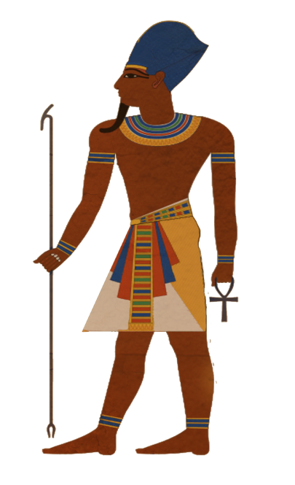

Context: It is 2580 B.C. You and your team have been hired by the Pharaoh Khufu as one of several teams of royal engineers who will potentially build his pyramid. To test your engineering skills, Khufu has designed a challenge where your team will have to build a mini pyramid out of every-day materials. The winning team will get to build his pyramid, a role that will give you much fame and glory.

Time Allowed: 30 minutes

Team Size: 3-4 students

Objective: To construct a standing square-based pyramid with the greatest height in the time given.

Materials for each group:

- Scissors
- Glue stick
- Scotch tape
- Masking tape
- Box of playing cards
- Spaghetti
- Plastic straws
- String
- Rubber bands
- Calculator
- Ruler
- Timer

Design Requirements:
- The pyramid can be open, meaning you only need to build its “skeleton” and do not have to fill in the walls (see picture on the right).
- The base of the pyramid must be square.
- Someone from your team must be able to move the pyramid from your desk to another desk without the pyramid breaking.
- You can use any of the construction materials given to you (see “Materials” above) and can manipulate the materials in any way.
- The pyramid must stand on its own for at least 30 seconds.
- The height will be measured from the base to the top of the pyramid where all four sides meet.

Example of an “open” pyramid:

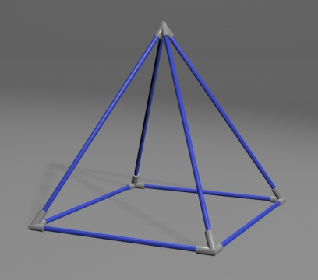

Hints:
- Budget your time carefully. It can go by much faster than you think.
- If you finish early, think about how you can improve your design or think of alternate designs.

Discussion Questions:
After the time is up for building and the teacher is walking around measuring your pyramids, each group should discuss the questions below.

- Briefly look at the other groups’ pyramids. How is your design similar to others in the room? How is it different?
- Did your group brainstorm different ideas before starting to build? If yes, approximately how much time did you spend on brainstorming and how did you choose the design that your group constructed? If no, how did you come up with the design for your pyramid?
- What were the roles of the different team members? How were roles assigned? What was your personal contribution to this project? Did you think you worked well together as a team? Why?
- What materials did you use for your pyramid? Why? Did you test the materials in any way before starting to build the pyramid?
- What changes did you make, if any, after beginning construction? Why did you make these changes?
- What was the biggest challenge your group faced? Were you able to overcome it? If yes, how did you overcome it?

Homework:
Answer the following question either using a paragraph or bullet points: If you and your team had an opportunity to build your pyramid again tomorrow, what would you do differently and why?

