Name: ____________________________________________________ Date: __________________
Class:___________
Teacher Handout (Class 2)

Follow along with the presentation to fill in the chart and questions.

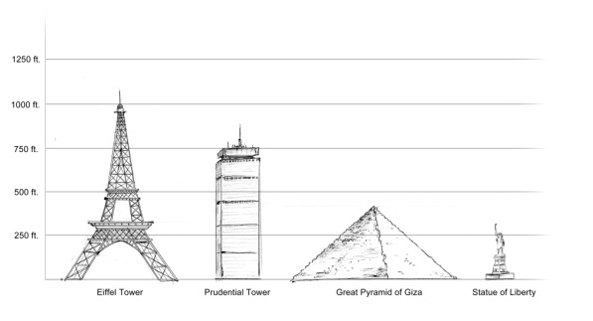
1. What were your team's criteria and constraints for building the pyramids yesterday?

Answers may include but limited to:
Criteria = Need to maximize height, square bottom
Constraints = Time, limited choice of materials, number of students on team

146 meters tall

Step One:
Identify the
Problem



60 Tons

2b. What are the benefits of researching and brainstorming possible solutions?

Answers may vary. Accept all appropriate responses.

2a. What were the three possible theories that Jean Pierre found?
Answers:
Wooden levers, massive external ramp, spiral ramp around outside of pyramid

Step Two:

Research and Brainstorm Solutions

3b. What were some design elements that worked well in class yesterday?

Answers may vary. Accept all appropriate responses.

3a. Which solution(s) did Jean-Pierre select?

Answer:
Jean-Pierre combined three of history’s best ideas into his own innovative theory. Each concept was tweaked to fit his idea of the best solution.

Step Three:
Select the Best Solution

(Steps 4-7 on back)
(Steps 1-3)
4b. Did your team make any changes or additions to your design during the construction process? Why?

Answers may vary. Accept all appropriate responses.

4a. Why did Jean-Pierre use 3D modeling and simulation software?
Answers may include but not limited to:
Quick and easy to Build/Change
Easy to Test/Evaluate
Easy to Transport/Share
Same Geometric and Physical properties

Step Four:
Construct a Prototype

Step Seven:
Communicate the Solution
5. Why do you think it is important to communicate your solution?

Answers may vary. Accept all appropriate responses.

Jean-Pierre has shared his ideas with the world in a variety ways including 3D experiences at omnimax theatres, such as La Geode in France.

Step Five:
Test and Evaluate the Solution

Step Six:
Redesign

