Pyramid Design Challenge
Student Instructions (Class 3)

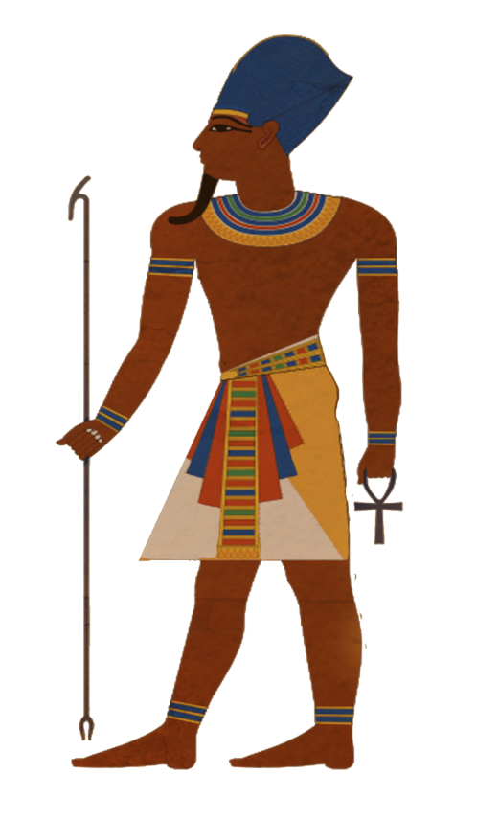
Context: The Pharaoh Khufu has once again summoned your team of engineers. While Khufu was impressed with the model pyramids from the last challenge, he had a change of mind and decided that this time instead of building the pyramid with the greatest height he wants to see which team can build the pyramid with the greatest volume. Also, this time Khufu not only wants to see your model pyramid, but wants you to stay within budget and to present your design to him. Can you impress the Pharaoh enough to be the team of engineers who will have the great honor of building Khufu’s Great Pyramid?

Time Allowed: 30 minutes to build and 20 minutes for putting together the presentation

Team Size: 3-4 students (the same group that you worked with on the previous challenge)

Objective: To construct a standing square-based pyramid with the greatest volume in the time given while staying within budget and preparing a short presentation about your design.

Materials that can be used:

- Scissors
- Calculator
- Ruler
- Timer
- Box of playing cards
- Spaghetti
- Plastic straws
- String
- Rubber bands
- Glue stick
- Scotch tape
- Masking tape

Design Requirements:
- The pyramid can be open, meaning you only need to build its “skeleton” and do not have to fill in the walls (see picture on the right).
- The base of the pyramid must be square.
- Someone from your team must be able to move the pyramid from your desk to another desk without the pyramid breaking.
- You can use any of the construction materials that are given to you and that you purchase and can manipulate the materials in any way.
- The pyramid must stand on its own for at least 30 seconds.
- You must measure the volume of the pyramid in cubic centimeters (see hints). The teacher will confirm your measurements after the time is up.

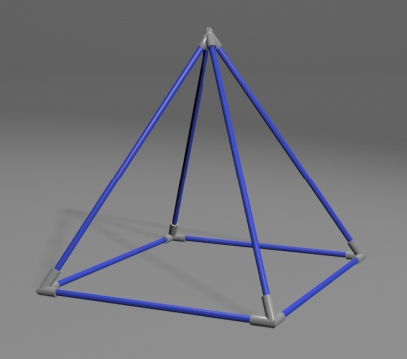

Budget:

Budget Requirement:
While your team’s objective is to maximize the volume of your pyramid you must also stay within budget. Your team will be given a pair of scissors, calculator, ruler and a timer and 200 Khufu Bucks that can be used to purchase materials from the teacher. You can purchase materials at any point during the construction process. Once you purchase materials you cannot sell them back, but you can trade materials with other teams at any point. Each of the construction materials has the following cost:

Construction Material | Cost  (in Khufu Bucks)
Playing card | 3
Piece of spaghetti | 2
Plastic straw | 10
Rubber band | 1
Cubit of string | 5
Cubit of masking tape | 15
Cubit of scotch tape | 10
Glue stick | 15

Note: a cubit is an ancient Egyptian unit that is
approximately the length of a forearm (46 cm).

Presentation Requirements:
- The presentation must be completed by the end of class.
- Your presentation should include any media that you think is appropriate (sketches, budget calculations, photographs of your pyramid at various stages, short video clips, etc.).
- Your presentation should address the following questions:
  - Which steps of the engineering design process did you follow, if any? Give evidence of how you followed each step.
  - What were the criteria and constraints of this challenge? How did these changes affect your design?
  - Why did you use the materials that you did this time?
  - What role(s) did each team member have?
  - What did you learn from the last design challenge that you accounted for in this one?
  - Did you incorporate the ideas of any other team? If so, how?
  - What was your biggest challenge this time? How did you attempt to overcome this challenge?
  - Would you change anything about your design process from today? If so, what would you change?

Hints:
- Try to follow the steps of the engineering design process that you learned yesterday (see last page of handout).
- Learning from your own mistakes or the mistakes of others is valuable. Think about what you or other groups did well (or not so well) last time.
- The volume of a square-based pyramid (see figure below) is given by the formula: one third times the area of the base time the height. Because the area of the base is the length of a side squared, you can calculate the volume as one third times the length squared times the height (see below). For example, if a pyramid has a square base of side 4 cm (l=4) and a height of 9 cm (h=9), to find its volume: V = ⅓ × l² × h = ⅓ × 4² × 9 = 48 cm³

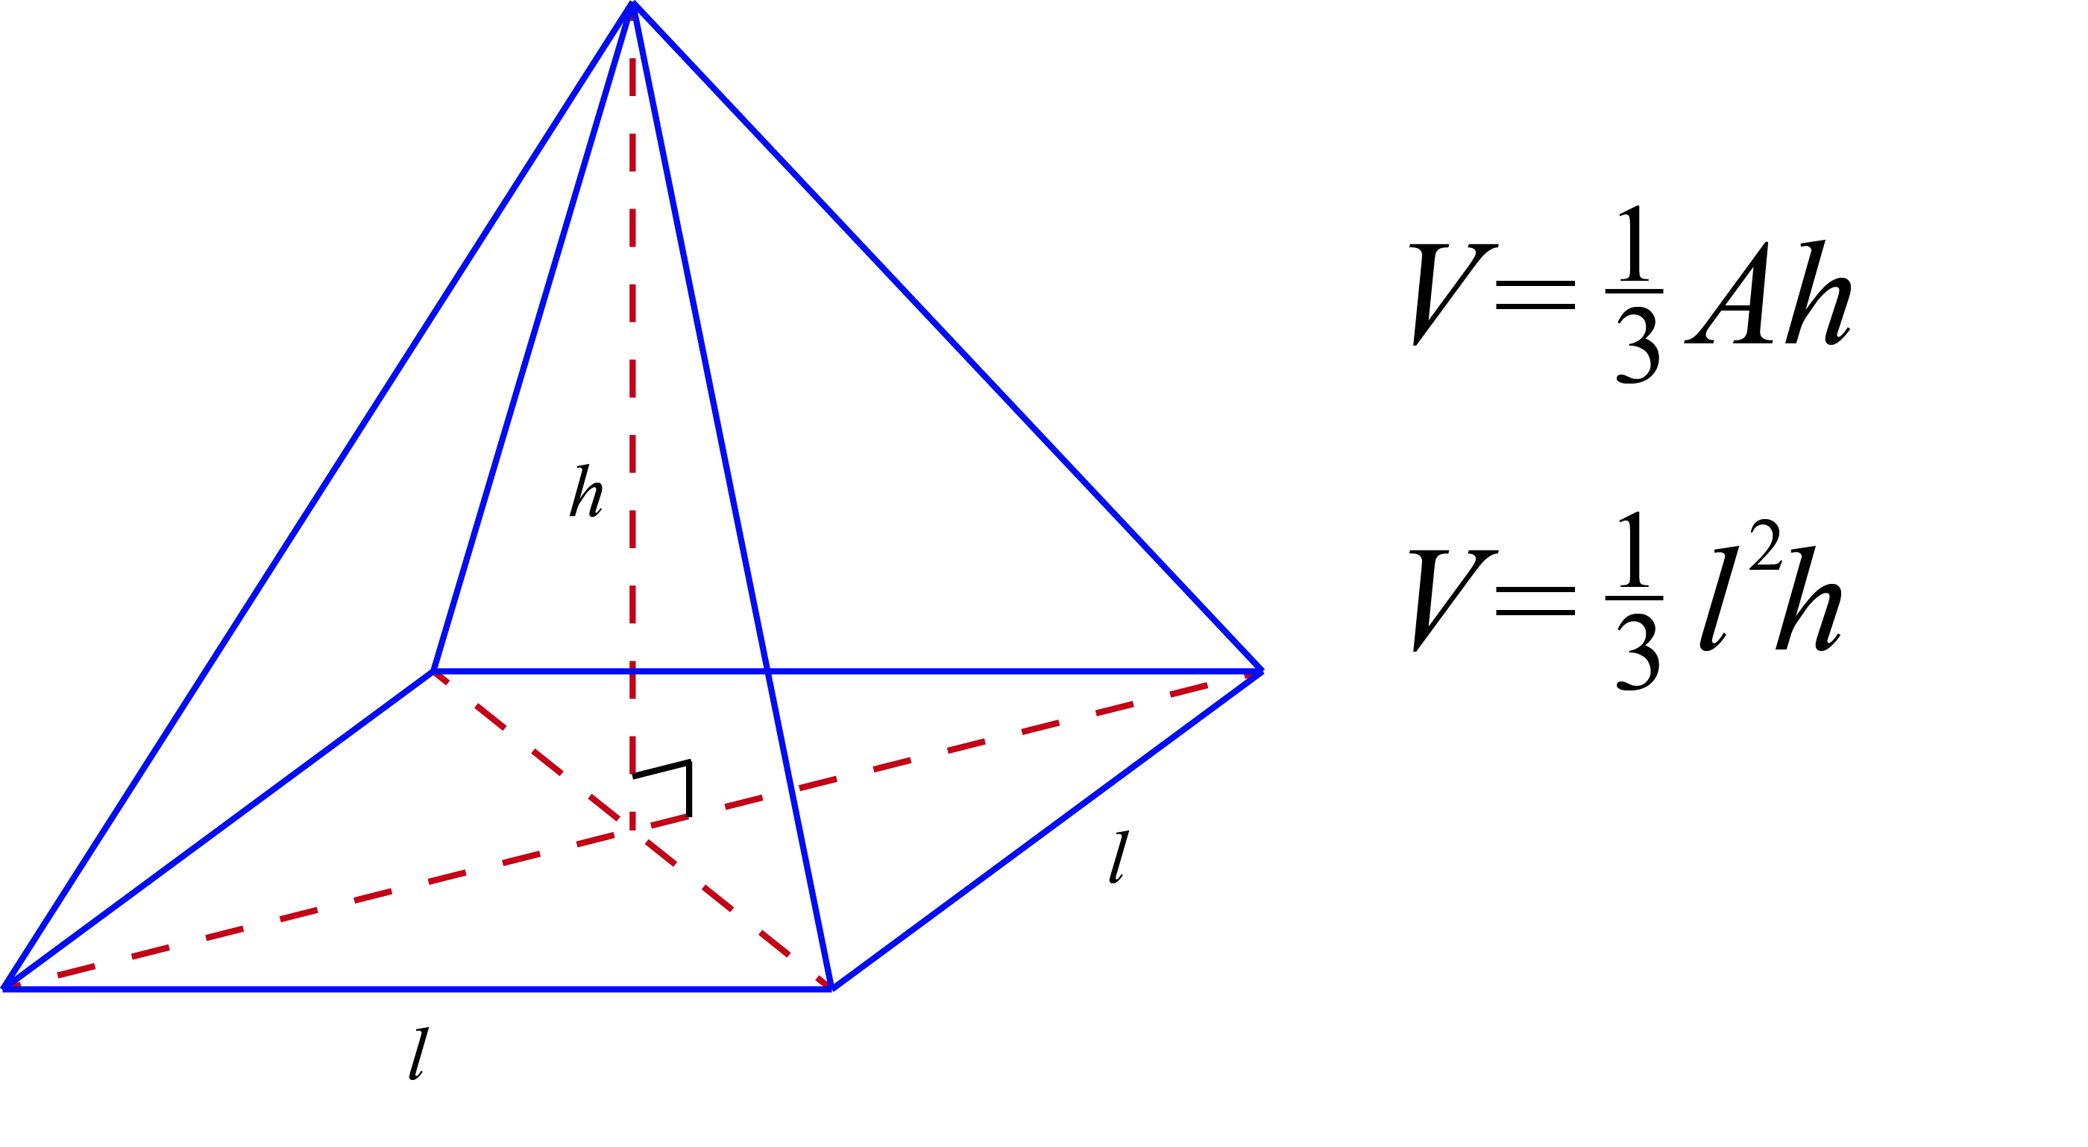

Grading Rubric:
Category | 0 points | 1 points | 2 points | Points:
Teamwork | Most team members were often off task and not cooperating or participating fully. | Some team members were occasionally off task or not participating fully. | Worked well together. All team members participated fully and stayed on task.
Following Engineering Design Process | Team followed almost no steps of the design process. | Team followed a few steps of the design process. | Team followed most of the steps in the design process.
Pyramid Construction | Pyramid does not satisfy design requirements (pyramid not fully constructed or collapses) | Pyramid satisfies some design requirements (base of pyramid not square or cannot be moved) | Pyramid is fully constructed and satisfies all design requirements
Presentation | Team gave a weak presentation by answering few of the questions satisfactorily and showed little understanding of the design process. | Team gave a basic presentation by answering some of the questions satisfactorily and showed a basic understanding of the design process. | Team gave a strong presentation by answering most of the questions satisfactorily and showed a clear understanding of the design process.
 |  |  | Total Points: | __ / 8

*** Bonus: Pyramid with the greatest volume: +1 point ***

Steps of the Engineering Design Process

