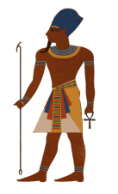
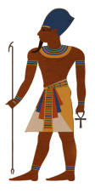
5
5

1
1

10
10

1
1
1

Khufu Bucks
Khufu Bucks
Khufu Bucks
Khufu Bucks

Khufu Bucks

Khufu Bucks

Khufu Bucks
Khufu Bucks

1

Khufu Bucks

